Hardware Design

**Lab 2 Report**

Advanced Gate-Level Verilog

**Team 01**

112062144 謝佳晉 112062144 范升維

Table of Contents:

Basic Q1. Nand Implement 1

Basic Q3. Difference between Half Adder and Full Adder 2

Advanced Q1. 8-bit Ripple Carry Adder (RCA) 3

Advanced Q2. Decode and execute 4

Advanced Q3. 8-bit CLA 4

Advanced Q4. 4-bit Multiplier 4

Advanced Q5. Exhaustive testbench design 4

FPGA: 7-Segment Display Control 5

Testbenches 7

A. 8-bit RCA 7

B. Decode and execute 7

C. 8-bit CLA 9

D. 4-bit Multiplier 9

What we have learned from Lab2? 9

Contributions 10

# Basic Q1. Nand Implement

▲ Figure 0.1: 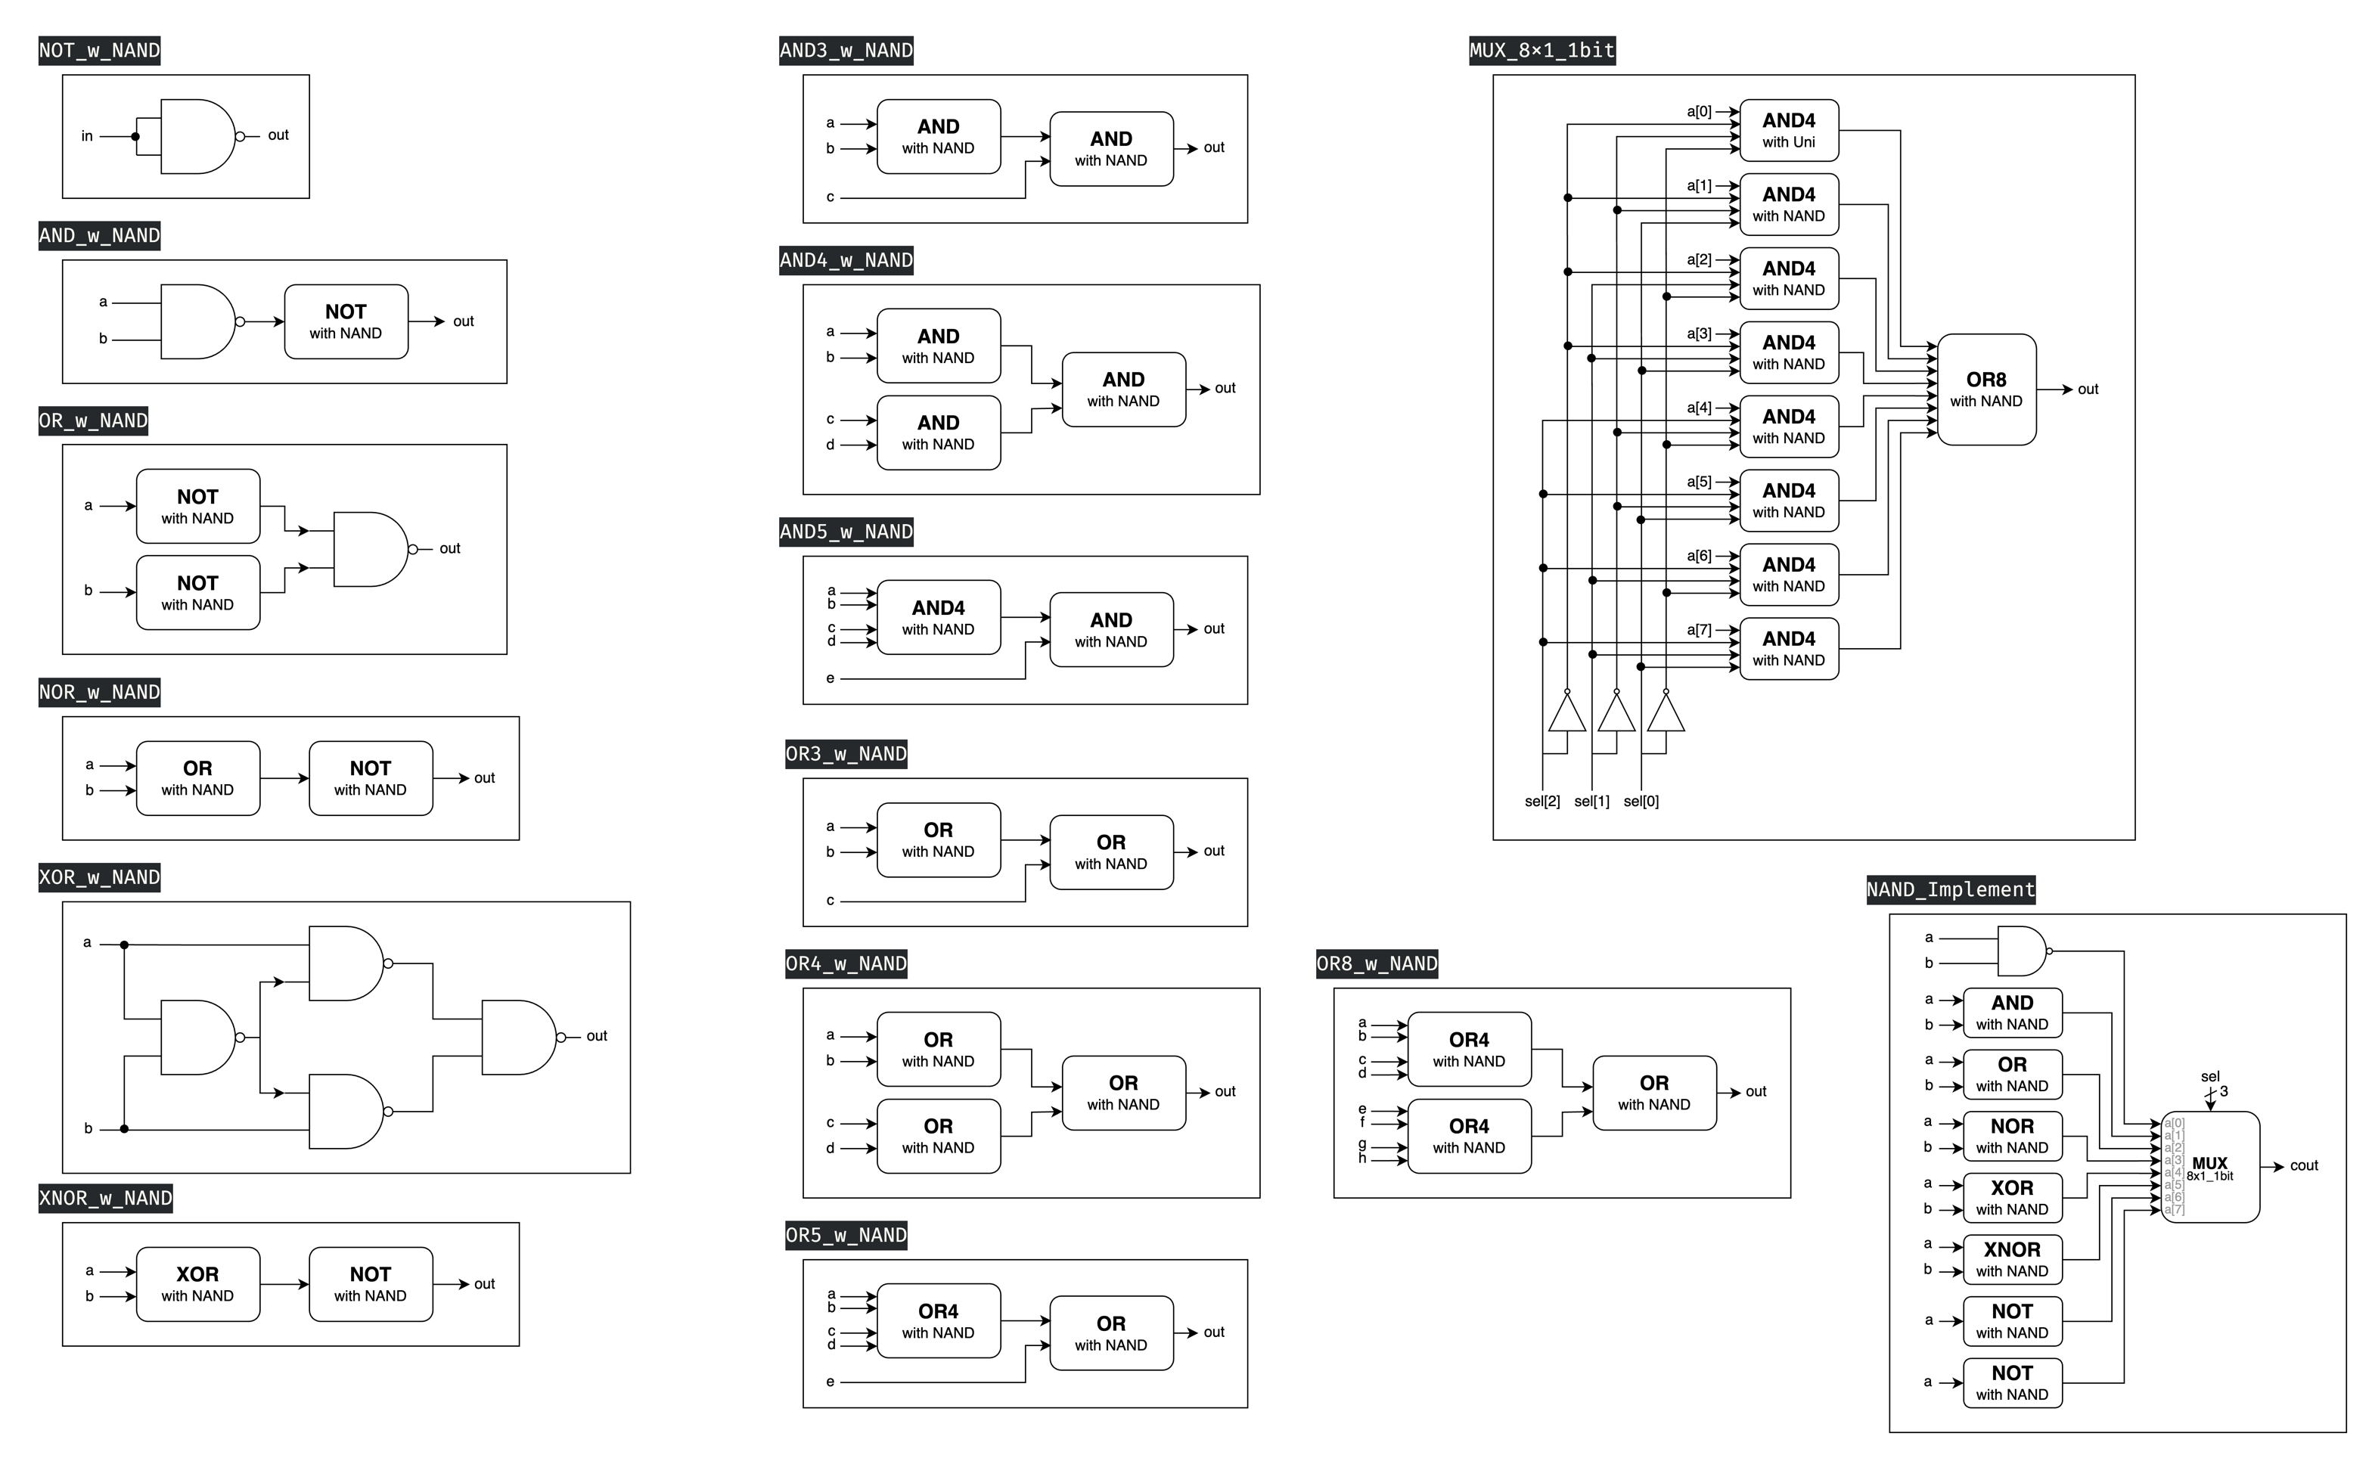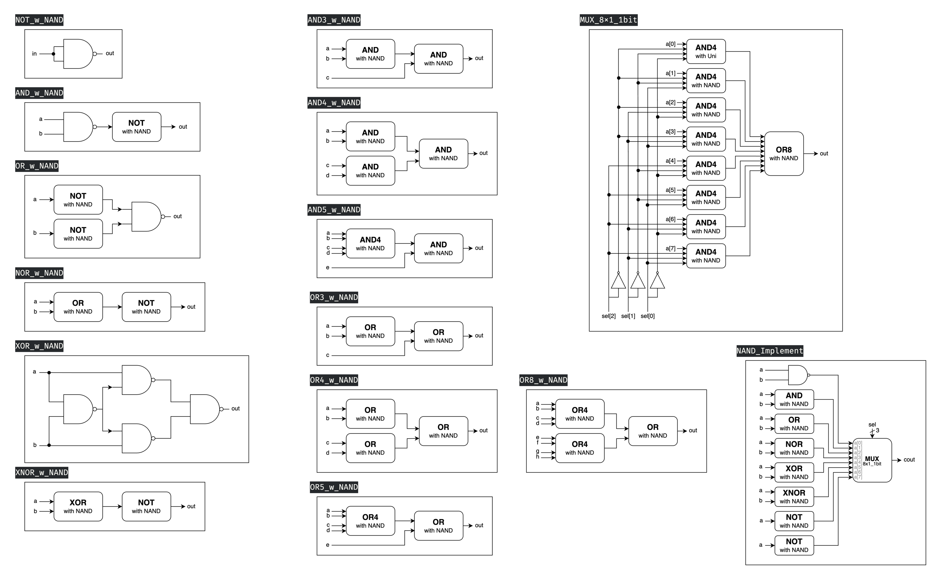8x1_1bit MUX ▲ Figure 0.2: NAND Implement

This problem requires us to utilize the NAND gate, which is a universal gate, to construct other basic gates. On the right side of the previous page, we have additionally implemented modules **AND3**, **AND4**, **AND5**, **OR3**, **OR4**, and **OR5**. These were prepared in advance for later use in the advanced Q3 section. Ultimately, we implemented an 8x1 1-bit multiplexer (**MUX**) to return the results of various basic gates in response to different input *sel* signals.

# Basic Q3. Difference between Half Adder and Full Adder

Half adders and full adders differ primarily in their input complexity and arithmetic capabilities. A half adder processes two single-bit inputs, generating a sum and carry output. In contrast, a full adder accommodates **three single-bit inputs**, including a carry-in, producing a sum and carry-out. This additional input enables full adders to **integrate previous calculation results**, making them suitable for complex arithmetic operations and multi-bit additions.

# Advanced Q1. 8-bit Ripple Carry Adder (RCA)

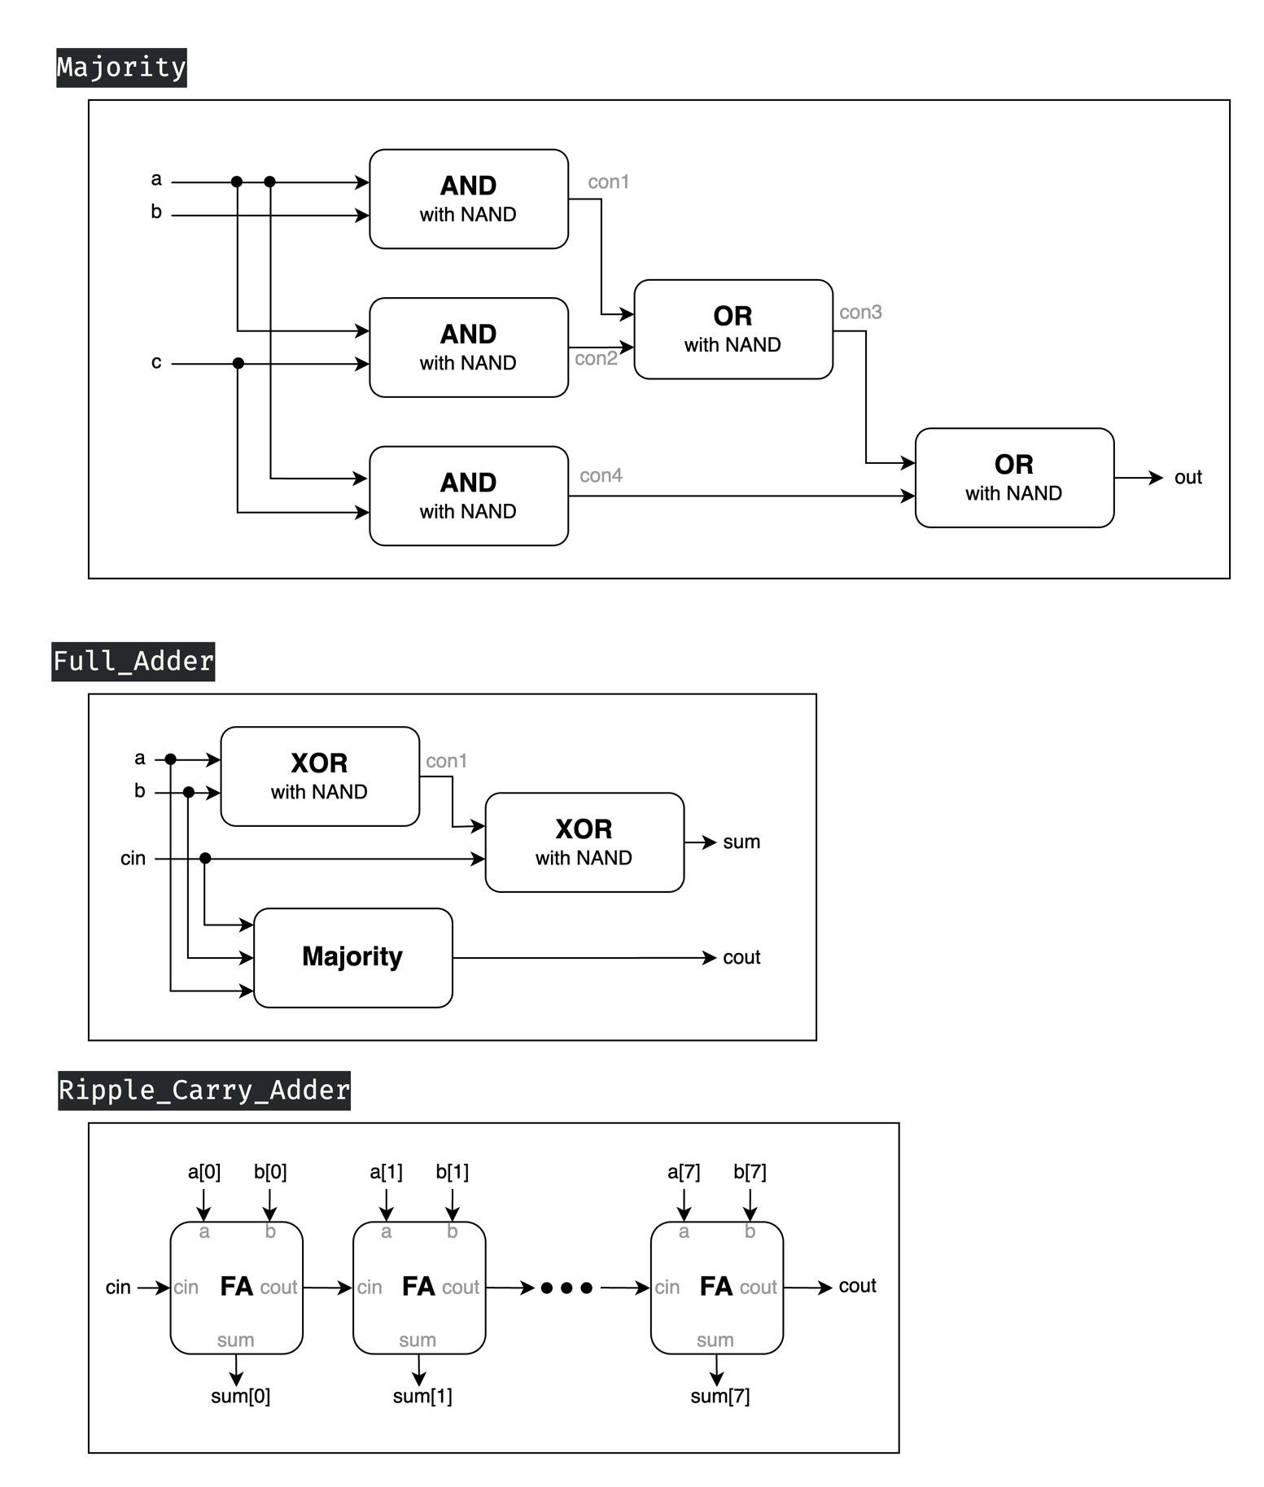  ▲ Figure 1.1: Majority ▲ Figure 1.2: Full Adder

▲ Figure 1.3: Ripple Carry Adder

* 3 inputs: *a[7:0], b[7:0], cin*
* 2 outputs: *sum[7:0], cout*

To construct a **8-bit RCA**, we use eight Full Adders connecting each other to calculate each sum and carry. The first(rightmost), second, third, …, seventh Full Adders produce carry, for the next Full Adder to take as *cin*, and the eighth Full Adder produce the overall carry of the final answer. Each bit of sum is calculated by each Full Adder respectively. Additionally, due to the demand that we could only use NAND gates, so all the basic gates we are supposed to use are replaced by our hand-made modules, and so does following advanced question 3 and 4.

# Advanced Q2. Decode and execute

▲ Figure 2.1: Basic Gates ▲ Figure 2.2: Basic Gates

By the requirement of the question that we could only use the specific universal gate, we first built some fundamental gates shown above for our later use.

▲ Figure 2.3: 4bit Ripple Carry Adder

Then, we constructed 4bit RCA with Full Adder, the structure of which are alike what we built in Q1, but all with specific universal gate modules.

  ▲ Figure 2.4: 4bit NOT ▲ Figure 2.5: 4bit Ripple Carry Adder - Minus

Next, to be able to easily manipulate the operation of "minus", we constructed a "**Minus version of RCA**" shown in Figure 2.5, using the mechanism of **Two's complement**, which is making the subtrahend number be negative by flipping all the bit of it and adding one to it.

After that, we needed to build bitwise OR, bitwise AND, Arithmetic Right Shift and Circular Left Shift, so we accomplished it by easily using the method shown on the above figures.

▲ Figure 2.5: Compare

Subsequently, we had to build the compare module, to distinguish two 4-bit number whether the first number is smaller than the second, or both of them are equal, the mechanism of which is that if their most significant bit is different (one is 1's, and the other is 0's), then the inequality can be seen, but if their MSB are the same, then check the second significant bit, and so on and so forth. After a series of comparison, if they are all the same, the *AeqB* signal will be 1's.

▲ Figure 2.6: 8x1 1bit MUX ▲ Figure 2.7: 8x1 4bit MUX

In the penultimate step, we constructed an 8x1 4-bit MUX by utilizing four 8x1 1-bit MUX. This approach enabled our final module to operate efficiently and concisely.

▲ Figure 2.8: Final Module(Decode and Execute)

* 2 inputs: *rs[3:0], rt[3:0]*
* 1 control signal: *sel[2:0]*
* 1 output: *rd[3:0]*

Finally, we reached the last step. We utilized the recently constructed 8x1 4-bit MUX along with all previously created modules to invoke the appropriate module based on the value of the *sel* signal, thereby generating the desired output. Of particular note are the last two compare modules, which only produce a single-bit output. As specified in the problem statement, the other three bits of these modules were assigned **predetermined** values. To accomplish this, we directly employed buffers (**BUF**) to assign these values.

# Advanced Q3. 8-bit CLA

**#TODO**

# Advanced Q4. 4-bit Multiplier

**#TODO**

# Advanced Q5. Exhaustive testbench design

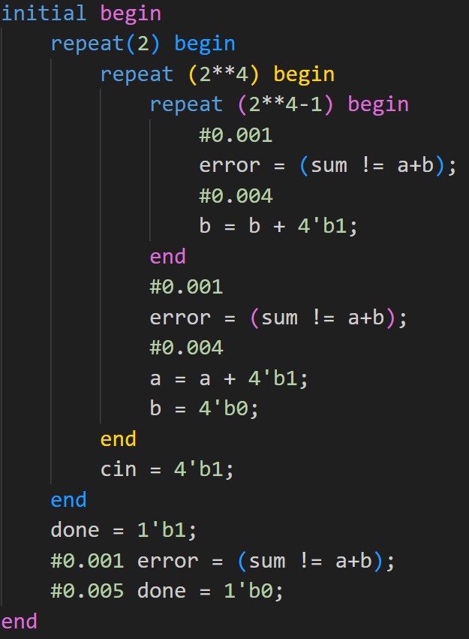▲ Figure 5.1: Our testbench design

To design a proper exhaustive testbench, we use “Three-level nested loop” to run all the number combinations we will encounter when using a 4-bit RCA. When the sum produced by the 4-bit RCA isn’t equal to the actual value, the error will be set to 1’b1 one nanosecond later and last for five nanoseconds. After the nested loop run out, we set done to 1’b1 in order to show that all of the combinations have been tested. Lastly, we reset done to 1’b0 after five nanoseconds.

# FPGA: 7-Segment Display Control

In order to light the rightmost 7-segment display, we set AN[0] to 1’b0 and AN[3:1] to 1’b1. 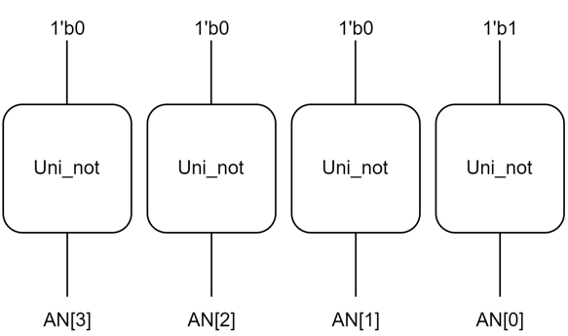

In the 7-segment display, we have to set the value of each segment port respectively according to the value of rd[3:0]. Below is the design of number displays.

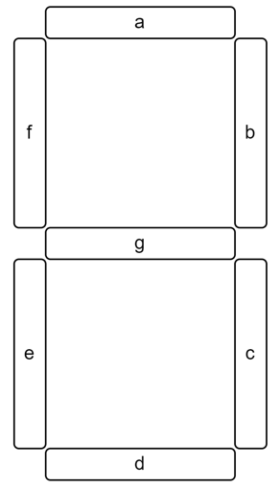 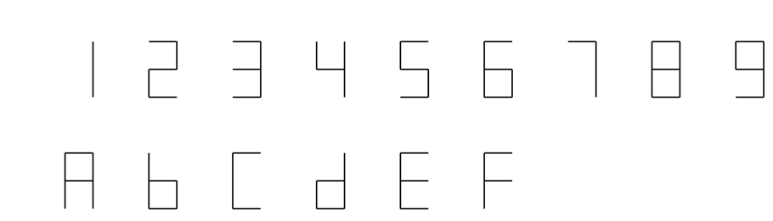

To set the value correctly, we have to draw K-map of each segment to get Boolean expressions. Take segment ‘a’ for example, we want to light up segment ‘**a**’ when rd[3:0] equals to 2, 3, 5, 6, 7, 8, 9, a, c, e, f, so we construct a K-map like this:

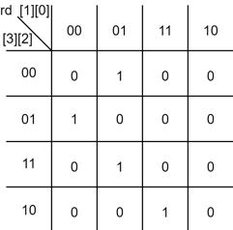

From this K-map, we can know the boolean expression of segment ‘**a**’ is:  
(rd[0]&(!rd[1])&(!rd[2])&(!rd[3]))|((!rd[0])&(!rd[1])&rd[2]&(!rd[3])) |(rd[0]&(!rd[1])&rd[2]&rd[3])|(rd[0]&rd[1]&(!rd[2])&rd[3])

We can get other 6 segments’ boolean expressions likewise:

**b:** (rd[0]&(!rd[1])&rd[2]&(!rd[3]))|((!rd[0]&rd[1]&rd[2])|(rd[0]&rd[1]&rd[3])| ((!rd[0]&rd[2]&rd[3])

**c:** ((!rd[0])&rd[1]&(!rd[2])&(!rd[3]))|(rd[1]&rd[2]&rd[3])|((!rd[0])&rd[2]&rd[3])

**d:** (rd[0]&(!rd[1])&(!rd[2])&(!rd[3]))|((!rd[0])&(!rd[1])&rd[2]&(!rd[3]))| ((!rd[0])&rd[1]&(!rd[2])&rd[3])|(rd[0]&rd[1]&rd[2])

**e:** (rd[0]&(!rd[3]))|(rd[0]&(!rd[1])&(!rd[2]))|((!rd[1])&rd[2]&(!rd[3]))

**f:** (rd[0]&(!rd[1])&rd[2]&rd[3])|(rd[0]&(!rd[2])&(!rd[3]))|(rd[1]&(!rd[2])&(!rd[3]))| (rd[0]&rd[1]&(!rd[3]))

**g:** (rd[0]&rd[1]&rd[2]&(!rd[3]))|((!rd[0])&(!rd[1])&rd[2]&rd[3])|((!rd[1])&(!rd[2])&(!rd[3]))

After we have all segments’ boolean expressions, we can construct the FPGA module with primitive logic gates.  
(output: light[3:0] ->AN[3:0], display[6:0] ->segment ‘g’, ‘f’, ‘e’, ‘d’, ‘c’, ‘b’, ‘a’)

# Testbenches

## 一張含有 文字, 螢幕擷取畫面, 軟體, 陳列 的圖片 自動產生的描述A. 8-bit RCA

We can test the module by using three level nested loop like advanced Q5 to run all the number combinations and see whether the output is correct. In the inner loop, we accumulate b to its extreme value. In the outer loop, we accumulate a to its extreme value and reset b to zero in order to properly initialize the next inner loop. Outside of the initial block, we use always block to change cin value periodically. In this way, we can monitor the change of output much easier.

#Some additional pictures:

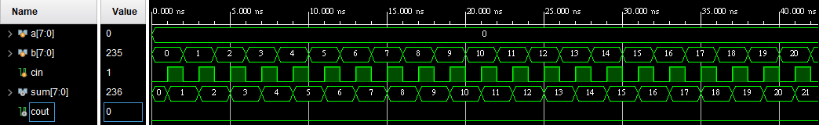 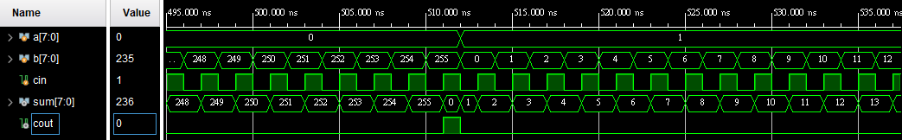 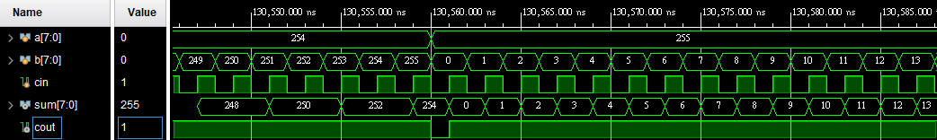 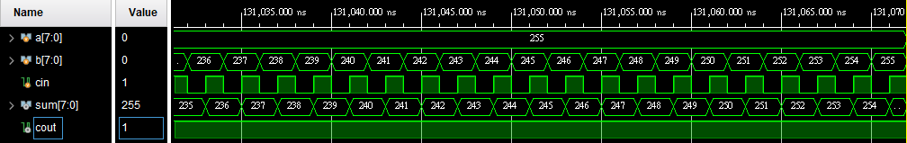

## B. Decode and execute

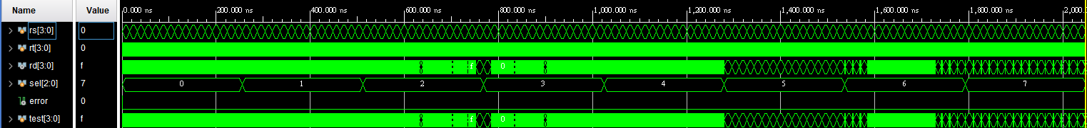

Steps:

Initialize->test ‘SUB’->reset->test ‘ADD’->reset->test ‘Bitwise OR’->reset->test ‘Bitwise AND’->reset->test ‘Right Shift’->reset->test ‘Left Shift’->reset->test ‘Compare LT’

->reset->test ‘Compare EQ’->finish

Whenever we test an operation out, we update the value of sel[2:0] to test the next operation. Besides, we have test[3:0] be the answer to the operation output.

To test ‘SUB’, ‘ADD’, ‘Bitwise OR’, ‘Bitwise AND’, ‘Compare LT’, and ‘Compare EQ’, we use two level nested loops to run all the 4-bit number combinations. If the output is not equal to test[3:0], the error will be set to 1’b1.

To test ‘Right Shift’ and ‘Left Shift’, we still use the two level nested loops because we want to test whether the outputs change with the unwanted input. Same, If the output is not equal to test[3:0], the error will be set to 1’b1.

#Some additional pictures:

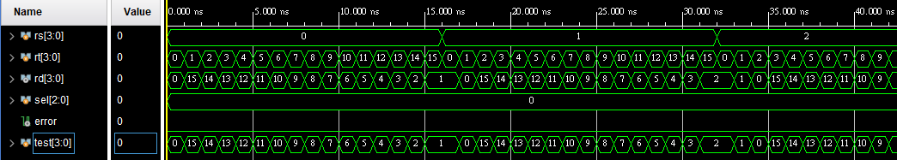

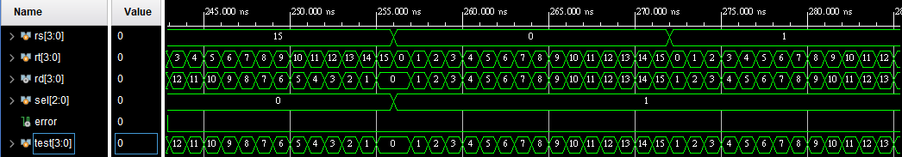

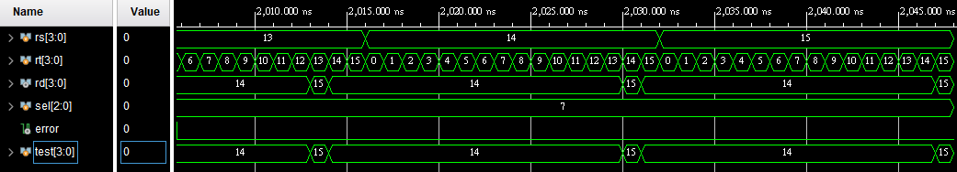

## C. 8-bit CLA

**#TODO**

## D. 4-bit Multiplier

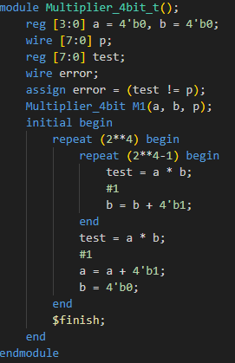

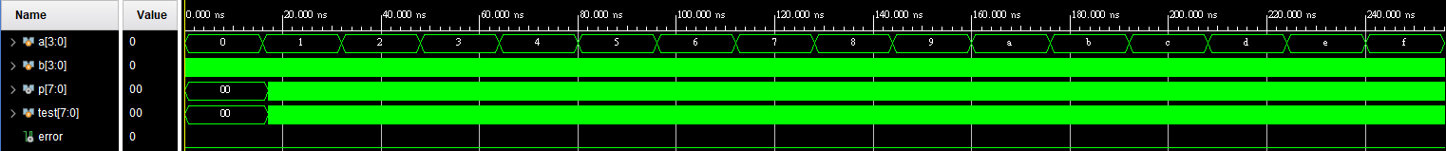

In order to test out all the possible output, we use two level nested loop to run all the number combinations and use signal ‘error’ to detect whether the output is correct.

When the value of p[7:0] is not equal to test[7:0], the error will be set to 1’b1 to show that the output is wrong.

#Some additional pictures:

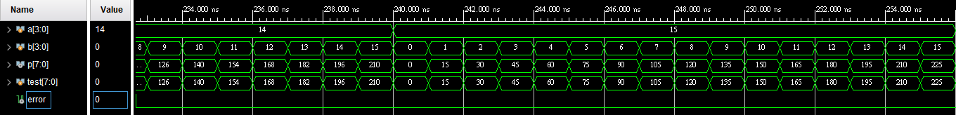

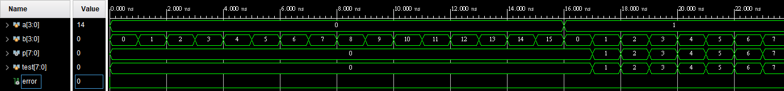

# What we have learned from Lab2?

**#TODO**

# Contributions

謝佳晉：

wrote Q1~Q4 Verilog

wrote testbench Q1~Q4

performed Q1~Q4 simulation on Vivado

drew diagram Q3, Q4

constructed report foundation with images and descriptions

made FPGA demonstration

范升維：

wrote Q1~Q4 Verilog

wrote testbench Q1~Q4

performed Q1~Q4 simulation on Vivado

drew diagram Q1, Q2

revised diagram Q3, Q4

organized, beautified report, added more descriptions and revised images

implemented FPGA demonstration